Locating a study that has been closed or withdrawn in Cayuse.

1. Log into Cayuse using your Franklin credentials
2. Click on the arrow next to Products (at the top of the screen) – select Human Ethics

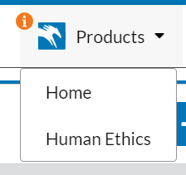

1. Click on the Studies tab – the default will only show your active studies

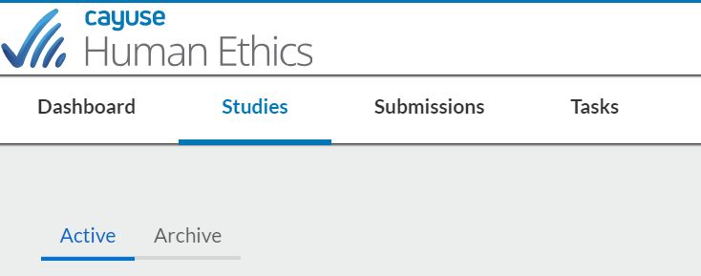

1. Click on the Archive tab – to see studies that have been closed or withdrawn

